Costume, Hair and Makeup

Acro Team

Costume: black or skin color leotard to go underneath unitard, black long sleeved unitard

Hair: two French style braids swirled into a low to mid bun in the back of the head and secured. No loose hair!

Makeup: foundation to match skin tone, black lipstick, eye makeup- see attached paper
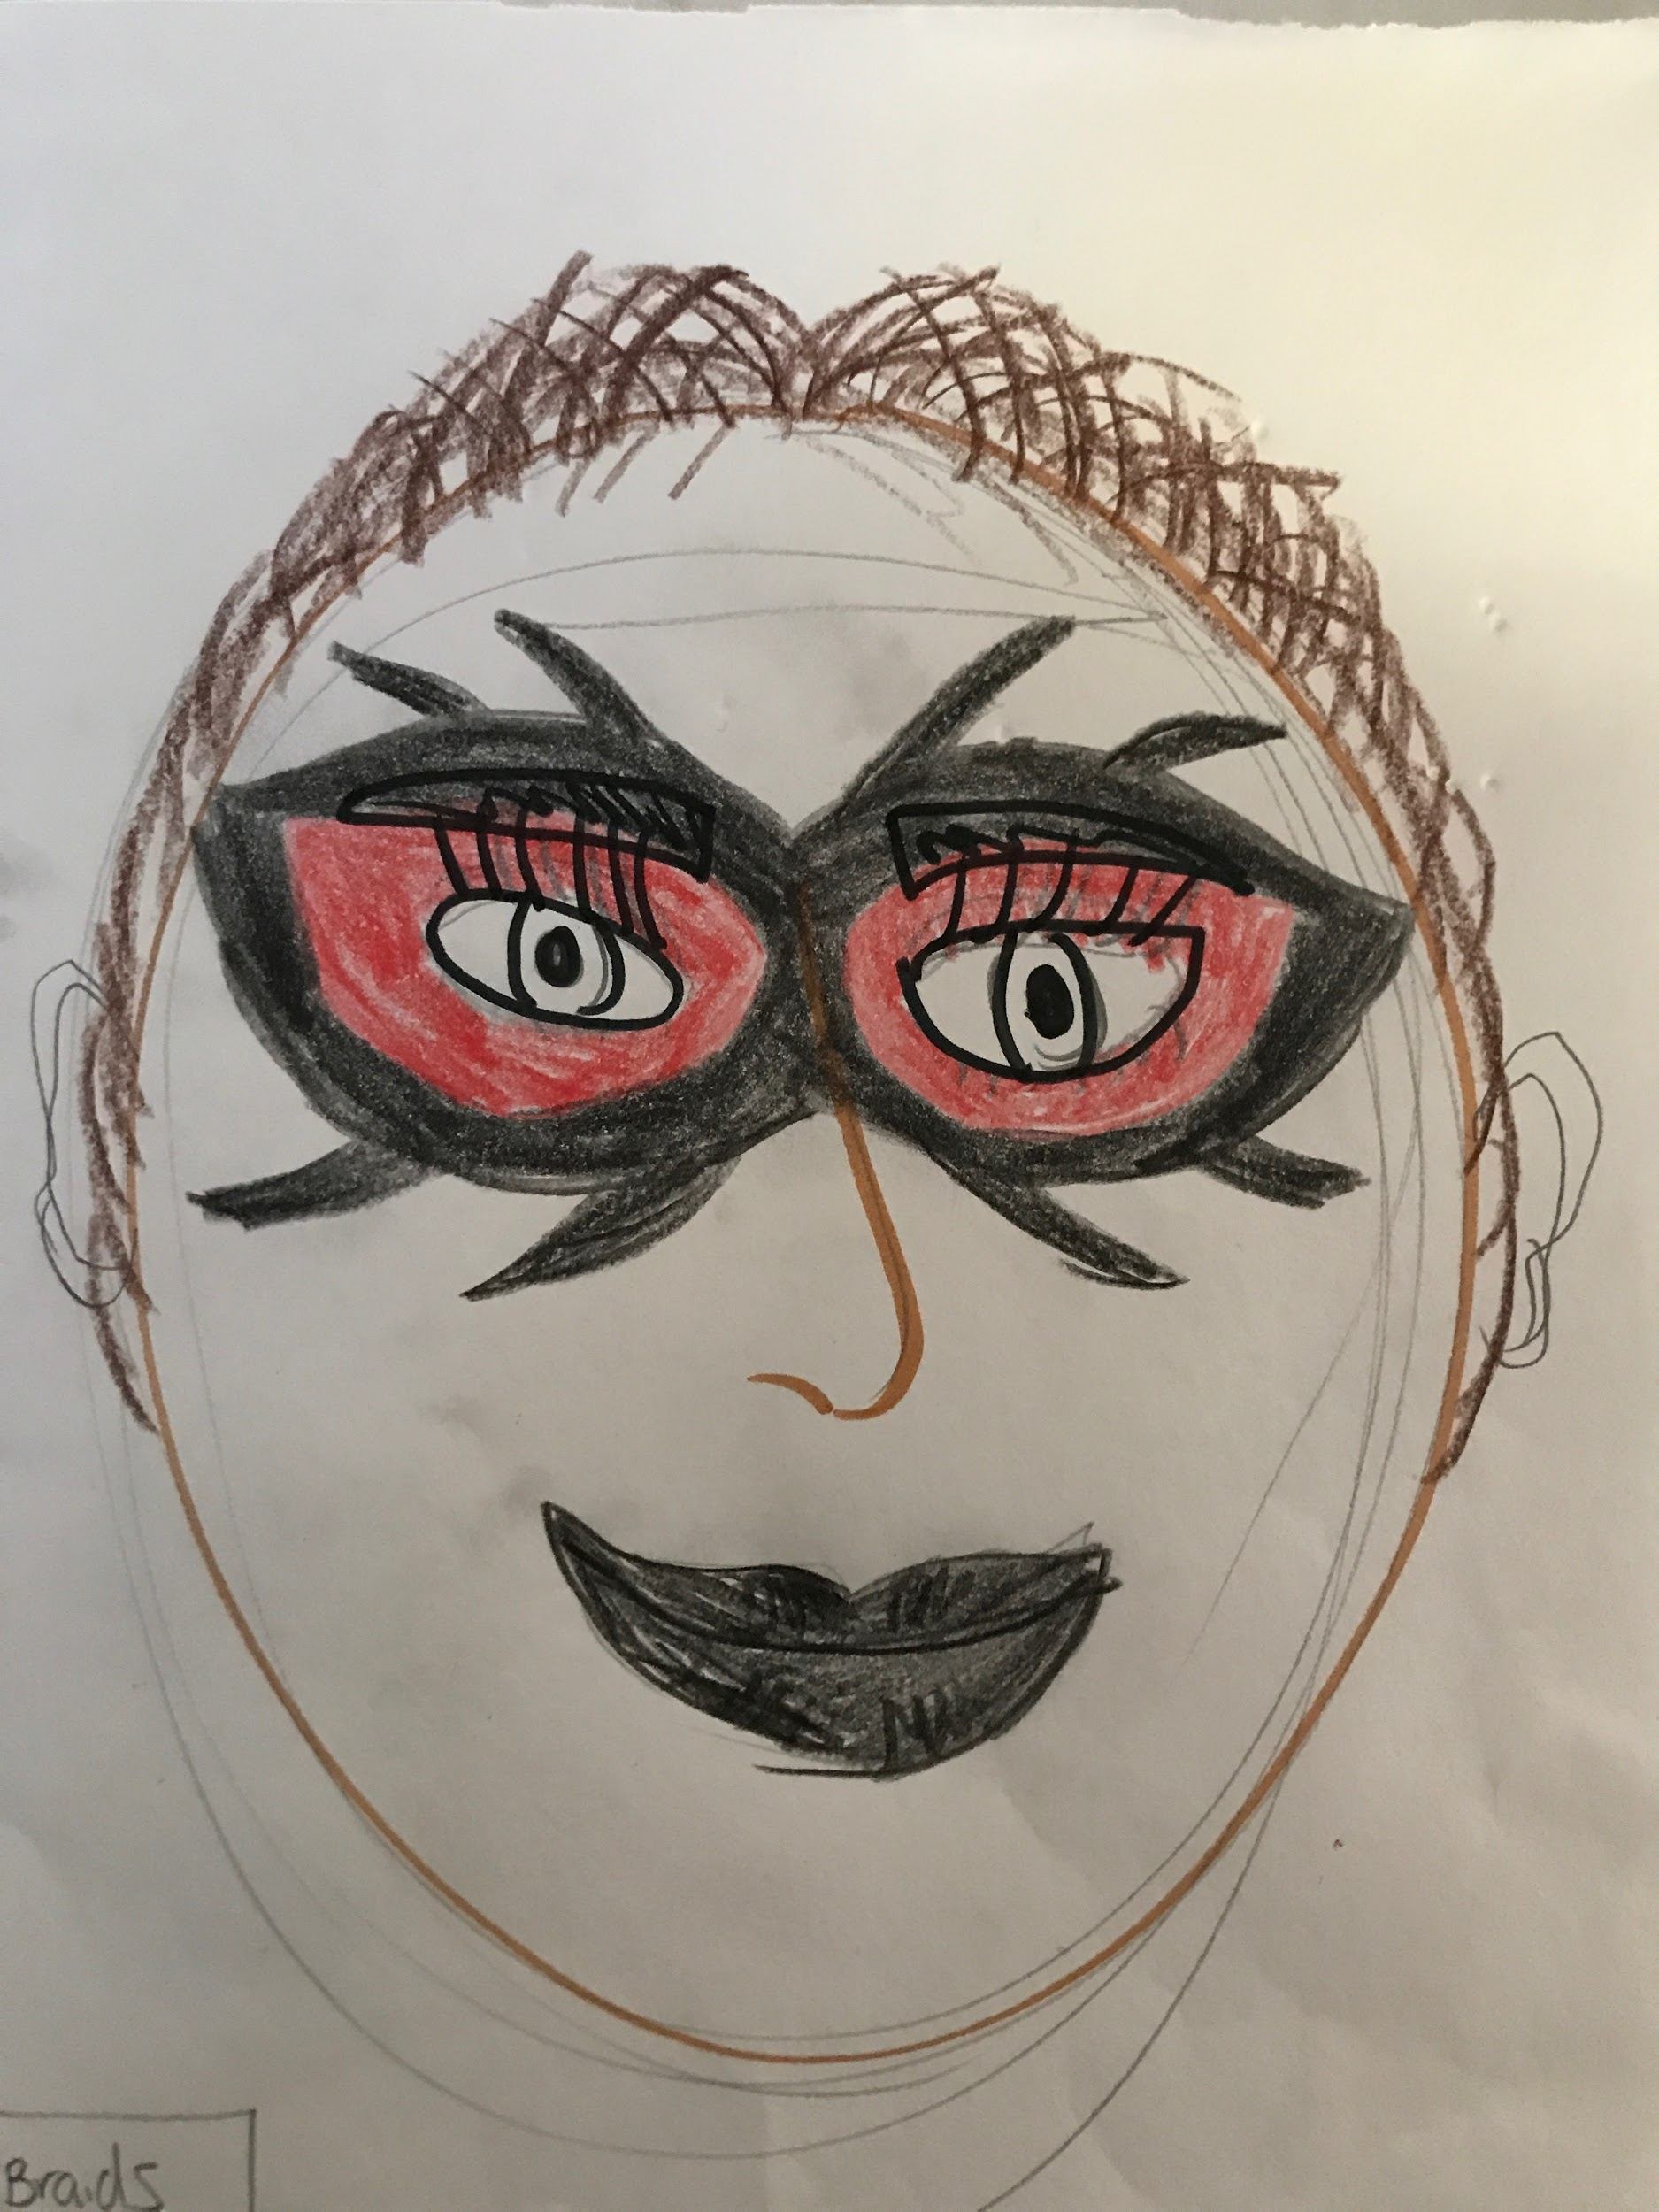

Junior Hip Hop Team

Costume: skin color leotard, white shirt, jacket, pants, neutral or white socks that do NOT show, white sneakers, white hat

Hair: mid side ponytail on the right side of your head, hat secured with Bobby pins and clips.

Makeup: foundation, black mascara, light pink cheeks, neutral to pink lipstick (no bright pinks!)

Senior Hip Hop Team

Costume: leotard (black or skin color), gold/green unitard, skin color performance tights- NOT NYLONS/PANTYHOSE!- socks if necessary that do not show, black boots

Hair: up do with braids- any kind of secured and sleek hairstyle with all hair pulled up and back in braid(s). If you do French braids you must tuck the ends under and pin them- no hair on shoulders!

Makeup: foundation, bronzer (gold tint), black fake eyelashes, black eyeliner, gold glittery eyelids, red lips

- 